# Project Planning Phase

**Project Planning (Product Backlog, Sprint Planning, Stories, Story points)**

|  |  |
| --- | --- |
| Date | 24 October 2022 |
| Team ID | PNT2022TMID38117 |
| Project Name | Retail Store Stock Inventory Analytics |
| Maximum marks | 8 |

## Product backlogs, Sprint schedule, Estimation(4 marks)

|  |  |  |  |  |  |  |
| --- | --- | --- | --- | --- | --- | --- |
| **Sprint** | **Functional Requirement(Epic)** | **User Story Number** | **User Story / Task** | **Story Points** | **Priority** | **Team Members** |
| Sprint-1 | Data Collection | USN-1 | The dataset is collected and the understanding of dataset is done to present the analytics to the user | 2 | High | Pavithra M Pooranapushpakala M Smiwin Gems  Suriya Lakshmi A |
| Sprint-1 | Data Preparation | USN-2 | As a user, I can view the accurate analytics of data by prepared data. The data preparation is done to restructure and clean  the data. | 3 | High | Pavithra M Pooranapushpakala M Smiwin Gems  Suriya Lakshmi A |
| Sprint-2 | Data Exploration | USN-3 | As a user, I can view the visualized data to get the better understanding about the sales, stock, revenue and price. | 8 | High | Pavithra M Pooranapushpakala M Smiwin Gems  Suriya Lakshmi A |
| Sprint-3 | Dashboard Creation | USN-4 | As a user, I can view the different visualization in the dashboard about the sales, stock, revenue and price. | 8 | High | Pavithra M Pooranapushpakala M Smiwin Gems  Suriya Lakshmi A |

|  |  |  |  |  |  |  |
| --- | --- | --- | --- | --- | --- | --- |
| **Sprint** | **Functional**  **Requirement (Epic)** | **User Story Number** | **User Story / Task** | **Story Points** | **Priority** | **Team Members** |
| Sprint-4 | Report creation | USN-5 | As a user, I can view the detailed report of the sales, stock, revenue and price. The user can get the report of the particular data. | 8 | High | Pavithra M Pooranapushpakala M Smiwin Gems  Suriya Lakshmi A |
| Sprint-4 | Story creation | USN-6 | As a user, I can view the story to get the better understanding of the sales, stock, revenue and price. The user can make decisions based on the story. | 8 | High | Pavithra M Pooranapushpakala M Smiwin Gems  Suriya Lakshmi A |

**Project Tracker, Velocity & Burndown Chart: (4 Marks)**

|  |  |  |  |  |  |  |
| --- | --- | --- | --- | --- | --- | --- |
| **Sprint** | **Total Story Points** | **Duration** | **Sprint Start Date** | **Sprint End Date (Planned)** | **Story Points Completed (as on Planned End Date)** | **Sprint Release Date (Actual)** |
| Sprint-1 | 5 | 6 Days | 24 Oct 2022 | 29 Oct 2022 | 5 | 29 Oct 2022 |
| Sprint-2 | 8 | 6 Days | 31 Oct 2022 | 05 Nov 2022 | 8 | 05 Nov 2022 |
| Sprint-3 | 8 | 6 Days | 07 Nov 2022 | 12 Nov 2022 | 8 | 12 Nov 2022 |
| Sprint-4 | 16 | 6 Days | 14 Nov 2022 | 19 Nov 2022 | 16 | 19 Nov 2022 |

**Velocity:**

Imagine we have a 10-day sprint duration, and the velocity of the team is 20 (points per sprint). Let’s calculate the team’s average velocity (AV) per iteration unit (story points per day)

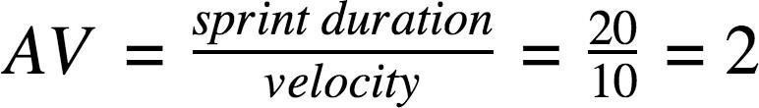

|  |  |  |  |
| --- | --- | --- | --- |
| **Sprint** | **Story points** | **Duration** | **Average velocity** |
| **Sprint-1** | 5 | 6 | 0.83 |
| **Sprint-2** | 8 | 6 | 1.33 |
| **Sprint-3** | 8 | 6 | 1.33 |
| **Sprint-4** | 16 | 6 | 2.66 |
| **Total** | 37 | 24 | 1.54 |

**Jira project planning:**

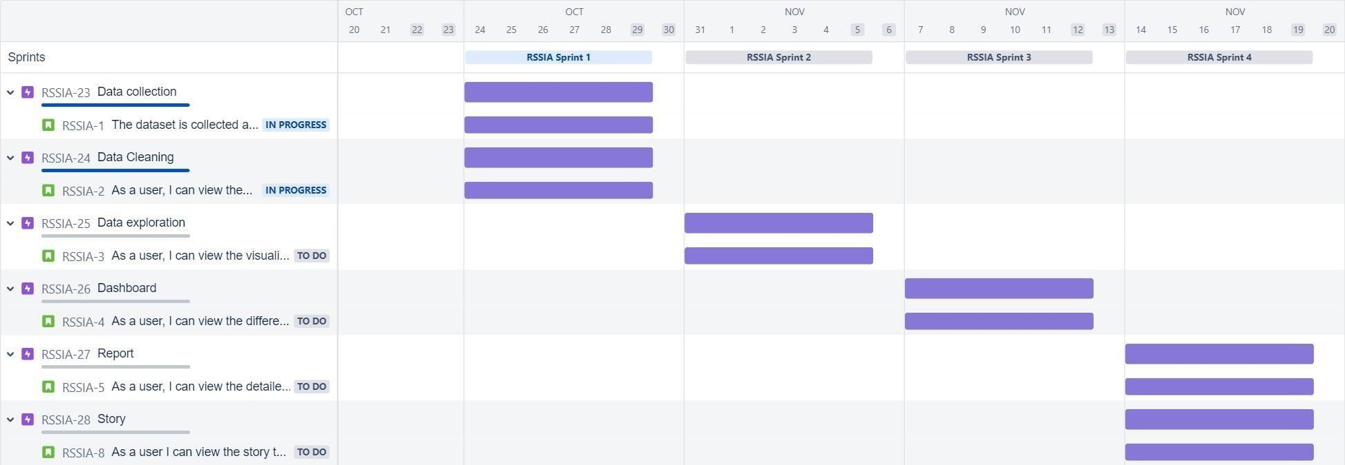

**Burndown Chart:**

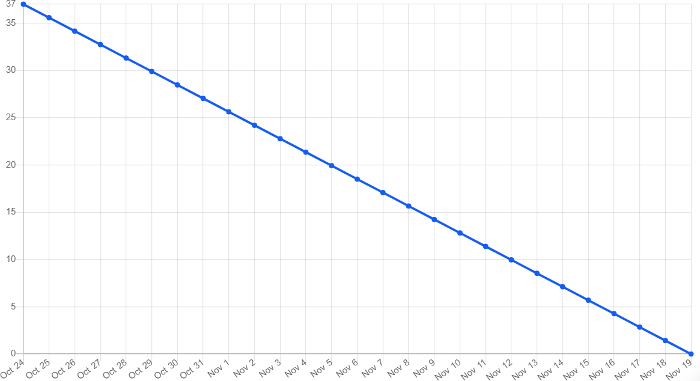

**Sprint-1**

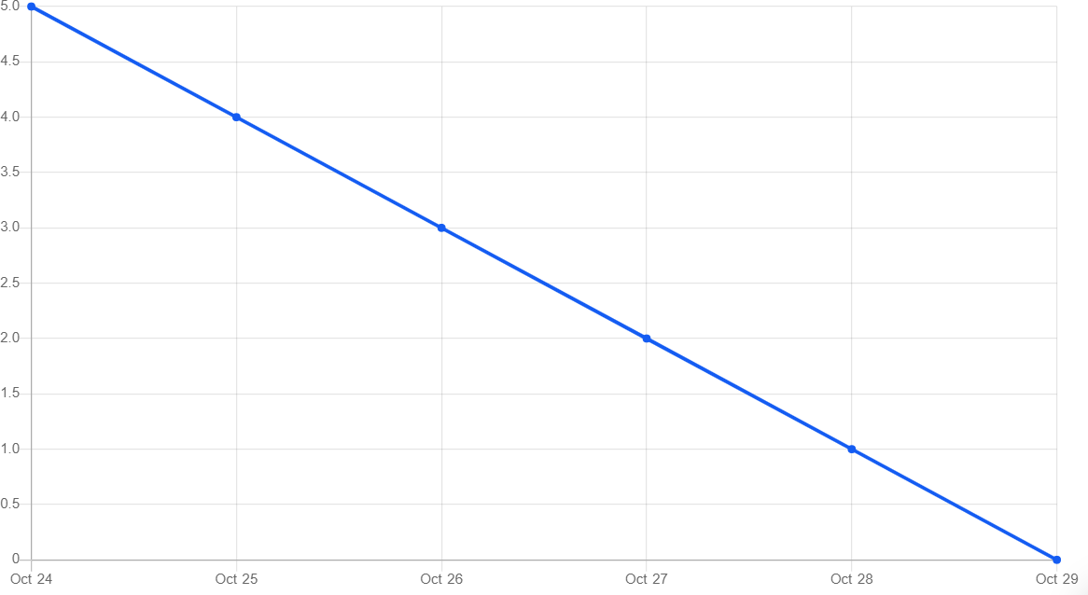

**Sprint-2**

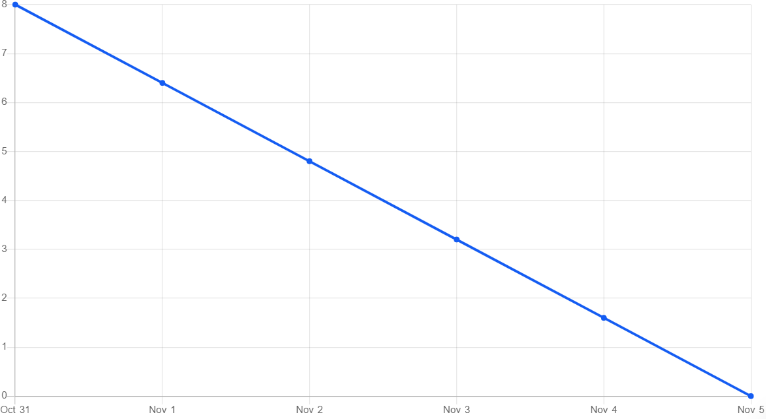

**Sprint-3**

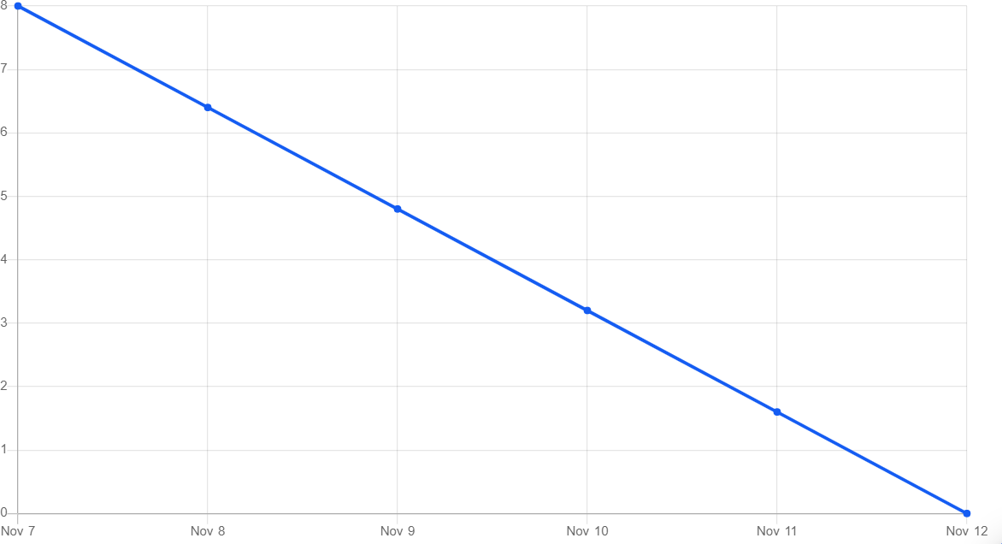

**Sprint-4**

